

DEPARTMENT OF COMPUTER SCIENCE AND ENGINEERING

U23CSP31 - DATABASE MANAGEMENT SYSTEMS LABORATORY

REGUALTION: 2023

LAB MANUAL

Prepared By Approved By

DEPARTMENT OF COMPUTER SCIENCE AND ENGINEERING
Vision
To produce globally competent, socially responsible professionals in the field of Computer Science and Engineering.
Mission
- Impart high quality experiential learning to get expertise in modern software tools
- Inculcate industry exposure and build inter disciplinary research skills.
- Mould the students to become Software Professionals, Researchers and Entrepreneurs by providing advanced laboratories.
- Acquire Innovative skills and promote lifelong learning with a sense of societal and ethical responsibilities
State the Program Educational Objectives (PEOs)
PEO 1: Graduates of the programme will develop proficiency in identifying, formulating, and resolving complex computing problems.
PEO 2: Graduates of the programme will achieve successful careers in the field of computer science and engineering, pursue advanced degrees, or demonstrate entrepreneurial success.
PEO 3: Graduates of the programme will cultivate effective communication skills, teamwork abilities, ethical values, and leadership qualities for professional engagement in industry and research organizations.
PROGRAMME SPECIFIC OUTCOMES (PSO):
Graduates of B.E. Computer Science and Engineering will be able to:
PSO 1: Analyze, develop and provide solutions to industrial problems in computer domain using programming, data processing and analytical skills.
PSO 2: Apply software application oriented skills to innovate solution to meet the ever changing demands of IT industry.

DEPARTMENT OF COMPUTER SCIENCE AND ENGINEERING
Program Outcomes (POs):
PO1: Engineering knowledge: Apply the knowledge of mathematics, science, engineering fundamentals, and an engineering specialization to the solution of complex engineering problems.
PO2: Problem analysis: Identify, formulate, review research literature, and analyze complex engineering problems reaching substantiated conclusions using first principles of mathematics, natural sciences, and engineering sciences.
PO3: Design / development of solutions: Design solutions for complex engineering problems and design system components or processes that meet the specified needs with appropriate consideration for the public health and safety, and the cultural, societal, and environmental considerations.
PO4: Conduct investigations of complex problems: Use research based knowledge and research methods including design of experiments, analysis and interpretation of data, and synthesis of the information to provide valid conclusions.
PO5: Modern tool usage: Create, select, and apply appropriate techniques, resources, and modern engineering and IT tools including prediction and modeling to complex engineering activities with an understanding of the limitations.
PO6: The engineer and society: Apply reasoning informed by the contextual knowledge to assess societal, health, safety, legal and cultural issues and the consequent responsibilities relevant to the professional engineering practice.
PO7: Environment and sustainability: Understand the impact of the professional engineering solutions in societal and environmental contexts, and demonstrate the knowledge of, and need for sustainable development.
PO8: Ethics: Apply ethical principles and commit to professional ethics and responsibilities and norms of the engineering practice.
PO9: Individual and team work: Function effectively as an individual, and as a member or leader in diverse teams, and in multidisciplinary settings.
PO10: Communication: Communicate effectively on complex engineering activities with the engineering community and with society at large, such as being able to comprehend and write effective reports and design documentation, make effective presentations, and give and receive clear instructions.
PO11: Project management and finance: Demonstrate knowledge and understanding of the engineering and management principles and apply these to one’s own work, as a member and leader in a team, to manage projects and in multidisciplinary environments.
PO12: Life - long learning: Recognize the need for and have the preparation and ability to engage in independent and life-long learning in the broadest context of technological change.

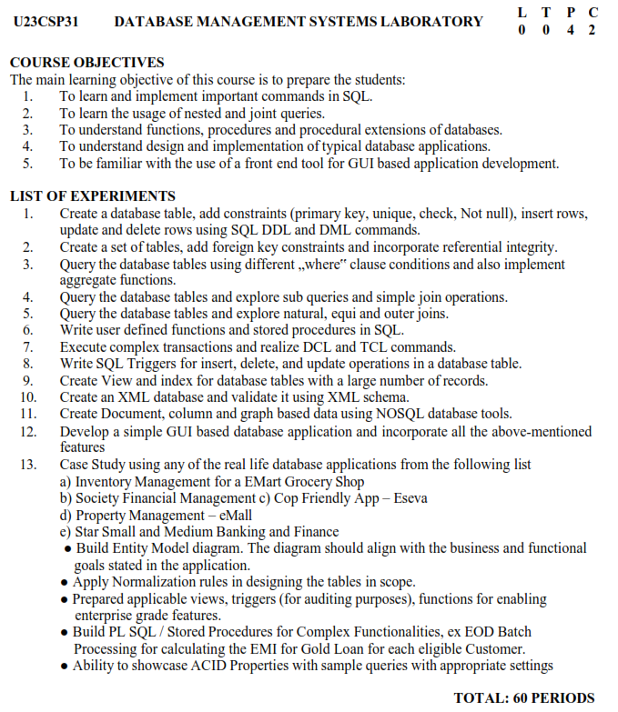

EX.NO:1a DATA DEFINITION COMMANDS

DATE:

AIM:

To implement database creation and do the operations in database using Data Definition

ALGORITHM:
Step 1: Create table by using create table command with column name, data type and size.
Step 2: Display the table by using select * from table name ; command.
Step 3: Add any new column with the existing table by alter table command.
Step 4: Modify the existing table with modify command.
Step 5: Delete the records in files by truncate command.
Step 6: Delete the Entire table by drop command.

CREATE TABLE Syntax:
create table table_name( column1 datatype, column2 datatype, column3 datatype,..... columnN datatype);

Example:

create table employee(id int,name varchar(100),age int,address varchar(100),salary float);
Table employee created

DESCRIBING THE TABLE

select * from employee;

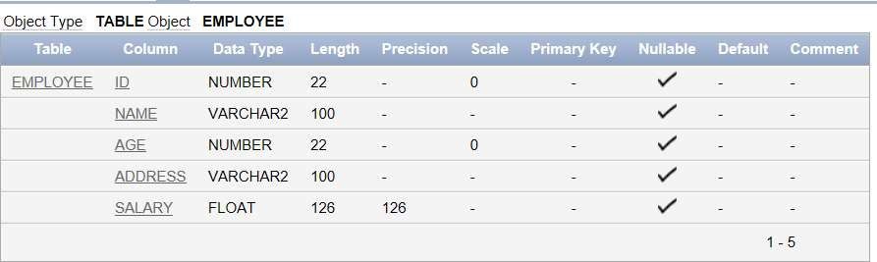

ALTER TABLE

Syntax: alter table table_name add column_name datatype;

Example:
alter table employee add dept varchar(10);

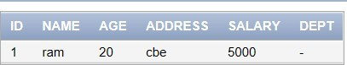
select * from employee;

Example:

alter table employee add (state varchar(100),weight float);
table employee altered.

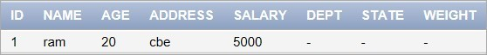
select * from employee;
table employee altered.

RENAME
To rename column name
Syntax: alter table table_name rename column existing _name to new_name;
Example:
EXEC sp_rename 'employee. address', 'addr', 'COLUMN';

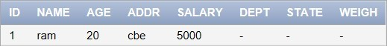
select * from employee

To rename table name
Syntax: EXEC sp_rename 'OldTableName', 'NewTableName';
Example:
EXEC sp_rename’employee’,’empl’;

select * from empl;

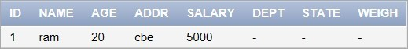

- TRUNCATE
Syntax: truncate table table_name;

Example:

truncate table emp; select * from empl;
no data found

DROP TABLE

Syntax:
drop table table_name;
Example: drop table empl; table customers dropped.

RESULT:
Thus the queries to implement data definition commands are executed successfully.

EX.NO:1b DATA MANIPULATION COMMANDS

DATE:

AIM:
To implement and execute a query for manipulating & storing data items in a Oracle database using Structured Query Language commands

ALGORITHM:
Step 1: Create table by using create table command.
Step 2: Insert values into the table
Step 3: Delete any records from the table
Step 4: Update any values in the table.
Step 5: Display the values from the table by using select command.

CREATE A TABLE
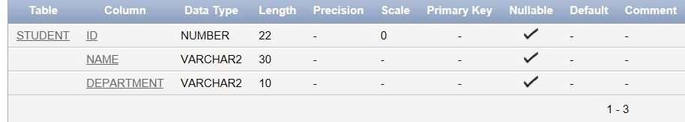
create table student(id int,Name varchar(30),Department varchar(10));

INSERT Syntax:
insert into table_name values(column1,column2,….);

Example:
insert into student values(1,'ABC','CSE'); insert into student values(2,'DEF','CSE'); select * from student;
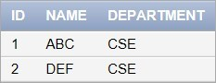

To insert NULL values to column:
The following syntax is used to insert NULL value to the column.

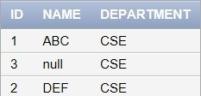
insert into student values(3,'null','CSE'); select * from student;

To insert default value to the column:
The following syntax is used to insert default value to the table.

Syntax:
insert into table_name values(column1,column2,…);

Example:
insert into student values(3,’alex’,default);
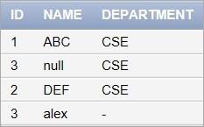
select * from student;

To insert data using select statement:
The following syntax is used insert all the values from another table using select statement.

Syntax:
insert into table_name1 select * from table_name2;

Example:
create table stud (id int,Name varchar(30),Department varchar(10)); insert into stud select * from student;

UPDATE Syntax:
update table_name set column1 = value1, column2 = value2. .. , columnn = valuen
where [condition];

Example: (single column)

update student set Department='ECE' where id=3;

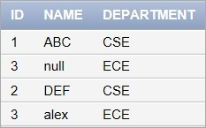
1rows updated.

Example: (multiple column)

update student set Name=’XYZ’,Department='CIVIL' where id=2;
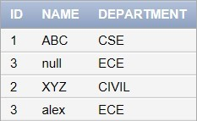

DELETE

Syntax: (delete particular row)
delete from table_name where condition;

Example:
delete from student where id=2;

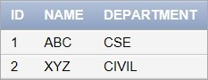

RESULT:
Thus, a query for manipulating & storing data items in an SQL server management studio using
Structured Query Language commands were implemented and executed successfully.

EX.NO:2 CREATE SET OF TABLES ADD FOREIGN KEY CONSTRAINT AND
DATE: INCORPORATE REFERENTIAL INTEGRITY

Aim:
To create set of tables add foreign key constraint and incorporate referential integrity using SQL.

Algorithm:
- Create two tables with a link that will not work.
- Create two tables with a link that will work.
- Add a foreign key to enforce referential integrity between the two tables.
- Delete data from the tables.
- Update and remove data to show how the foreign key protects the data.
- Use the cascade option of the foreign key.
- Companies table: List of Companies
- Employees table: List of Employees working at the Company
- Rule: Employees can only work at one Company, and a Company can employ multiple Employees

Program:

CREATE TABLE Department (
DepartmentID int PRIMARY KEY,
DepartmentName NVARCHAR (100)
);
CREATE TABLE Employee (
EmployeeID INT PRIMARY KEY,
FullName NVARCHAR(100),
DepartmentID INT,
CONSTRAINT FK_Employee_Department FOREIGN KEY (DepartmentID)
REFERENCES Department(DepartmentID)
ON DELETE CASCADE
ON UPDATE CASCADE
);
select * from Department;
select * from Employee;

INSERT INTO Department (DepartmentID, DepartmentName)
VALUES
(1, 'Human Resources'),
(2, 'Finance'),
(3, 'Research and Development'),
(4, 'Marketing'),
(5, 'IT Support');
INSERT INTO Employee (EmployeeID, FullName, DepartmentID)
VALUES
(101, 'Alice Johnson', 1), -- HR
(102, 'Bob Smith', 2), -- Finance
(103, 'Charlie Brown', 3), -- R&D
(104, 'Diana Prince', 4), -- Marketing
(105, 'Ethan Hunt', 5); -- IT Support
select * from Department;
select * from Employee;

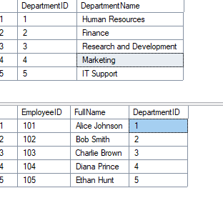

RESULT:
Thus, to create a set of tables add foreign key constraint and incorporate referential integrity were executed successfully.

EX.NO:3 DATABASE TABLES WITH DIFFERENT 'WHERE CLAUSE' CONDITIONS AND IMPLEMENT AGGREGATE FUNCTIONS
DATE:

Aim:
To using query the database tables with different 'where clause' conditions also implement
aggregate function with algorithm

Algorithm:
- Creating a table
- Inserting values
- Using various WHERE clauses
- Applying aggregate functions

Algorithm Steps for Aggregate Queries
  - Filter Data using WHERE clause (based on value, pattern, range, etc.).
  - Group Data using GROUP BY if needed.
  - Apply Aggregate Function (SUM, COUNT, AVG, MIN, MAX).
  - Optionally Filter Groups using HAVING.
  - Return Results.

Step 1:
CREATE TABLE salesdata (
sale_id INT PRIMARY KEY,
employee_name VARCHAR(50),
department VARCHAR(50),
sale_amount DECIMAL(10,2),
sale_date DATE,
region VARCHAR(30)

);
select * from salesdata;

Step 2:
INSERT INTO salesdata (sale_id, employee_name, department, sale_amount, sale_date, region) VALUES
(1, 'Alice', 'Electronics', 1200.00, '2025-01-15', 'North'),
(2, 'Bob', 'Furniture', 800.00, '2025-02-20', 'South'),
(3, 'Charlie', 'Electronics', 1500.00, '2025-03-05', 'North'),
(4, 'Diana', 'Clothing', 600.00, '2025-04-10', 'East'),
(5, 'Ethan', 'Furniture', 900.00, '2025-05-15', 'West'),
(6, 'Fiona', 'Electronics', 1800.00, '2025-06-01', 'North'),
(7, 'George', 'Clothing', 500.00, '2025-06-20', 'East'),

(8, 'Hannah', 'Furniture', 1000.00, '2025-07-01', 'South);

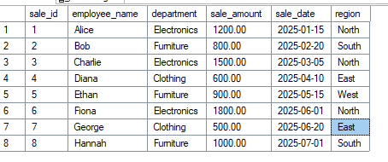
a.Equality
SELECT * FROM salesdata where department = 'Clothing';

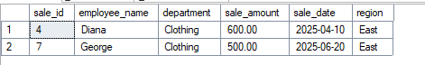

b.Greater Than

SELECT * FROM salesdata WHERE sale_amount > 600.00;
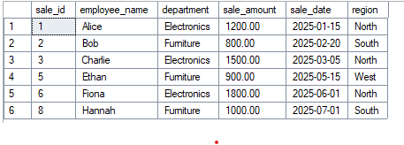
- BETWEEN (Date Range)
SELECT * FROM salesdata WHERE sale_date BETWEEN '2025-01-15' AND '2025-06-20';
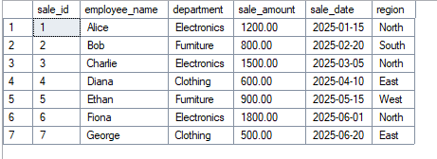
d. LIKE (Pattern Matching)
SELECT * FROM salesdata WHERE employee_name LIKE 'B%';
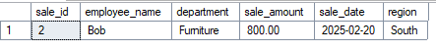

- NOT EQUAL
SELECT * FROM salesdata WHERE region <> 'North';

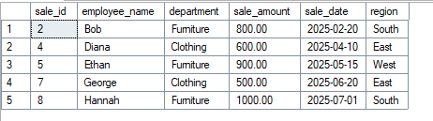
- IN Clause
SELECT * FROM salesdata WHERE department IN ('Electronics', 'sale_amount');
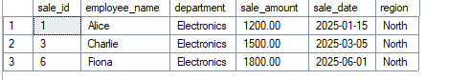

- IS NULL
UPDATE salesdata SET region = NULL WHERE sale_id = 5;

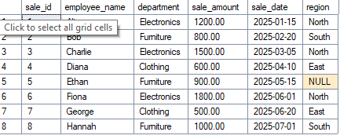
- AND / OR Combination
SELECT * FROM salesdata WHERE department = 'Electronics' AND sale_amount > 1300;

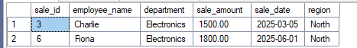

STEP 3: Queries with Different WHERE Clauses + Aggregate Functions

Total Sales in North Region
SELECT SUM (sale_amount) AS total_sales_north FROM salesdata WHERE region = 'North';
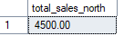
- Count of Sales Above $1000
SELECT COUNT(*) AS sales_over_1000 FROM salesdata WHERE sale_amount > 1000;
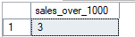
- Average Sale Amount for Furniture Department
SELECT AVG(sale_amount) AS avg_furniture_sales FROM salesdata WHERE department = 'Furniture';
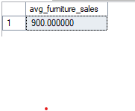
- Minimum Sale in Electronics (June or Later)
SELECT MIN(sale_amount) AS min_electronics_sales_june_onward FROM salesdata
WHERE department = 'Electronics' AND sale_date >= '2025-06-01';
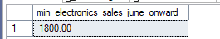
- Max Sale in Each Department (Grouped Aggregation)
SELECT department, MAX(sale_amount) AS max_sale FROM salesdata GROUP BY department;
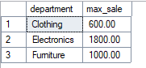
- Total Sales per Region (Only if More Than 1 Sale)
SELECT region, COUNT(*) AS num_sales, SUM(sale_amount) AS total_sales FROM salesdata
GROUP BY regionHAVING COUNT(*) > 1;
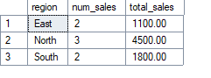

RESULT:
Thus the SQL query the database tables with different 'where clause' conditions also implement aggregate function are executed successfully.

EX.NO:4 SIMPLE QUERIES, SUB QUERIES, JOINS

DATE:

AIM:
To implement Simple queries, Nested queries, Sub queries using structured query language

ALGORITHM:

STEP 1: Create a table with the columns that are needed
STEP 2: Write simple queries to insert, delete, update and implement some functions
STEP 3: Write nested queries using clauses to retrieve data from the table
STEP 4: The nested queries may have more than one sub queries.
STEP 5: Efficiently retrieve data from the table.
QUERIES:
create table salary(id int, Name varchar(20),Age int,Salary float);
insert into salary (id,Name,Age,Salary) values(1,'Ajay',25,20000),
(2,'Archana',28,30000),
(3,'Archana',23,25000),
(4,'Sara',24,20000),
(5,'Ajay',25,40000),
(6,'Srinithi',26,35000);
select * from salary;
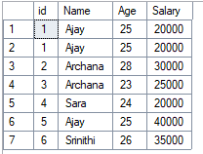

Sum function
Syntax:
select column_name1,sum(column_name2)from table_name group by column_name3;

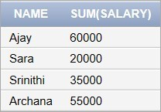
Example: select name, sum(salary) from salary group by name;

Min function

Syntax:
select column_name1,min(column_name2)from table_name group by column_name3;

Example:
select name, min(salary) from salary group by name;

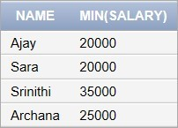

Max function
Syntax:
select column_name1,max(column_name2)from table_name group by column_name3;

Example:
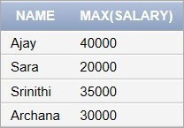
select name, max(salary) from salary group by name;

Count function

Syntax:
select column_name1,count(column_name2)from table_name group by column_name3;

Example:
select name, count(salary) from salary group by name;
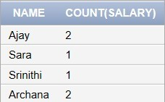

Mod function

Syntax:
select column_name1,mod(column_name2)from table_name;

Example:
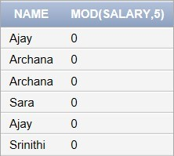
select name,mod(salary,5) from salary;

DISTINCT and ORDER BY Clause

Syntax:
select distinct column1, column2, columnn from table_name;

Example:
select salary from salary order by salary;

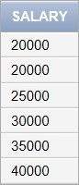

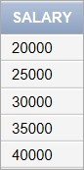
select distinct salary from salary order by salary;

HAVING clause
Example:

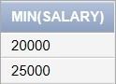
select min(salary)from salary group by age having max(salary)<30000;
Select using Conditions

AND
Example:
select * from salary where age >= 25 and salary >= 25000;
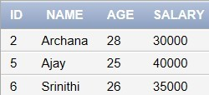

OR
Example:
select * from salary where age >= 25 or salary >= 25000;
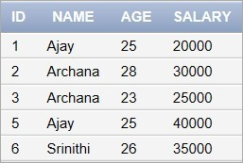

LIKE
select * from salary where name like 'Aj%';
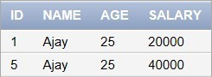

IN

select * from salary where age in ( 25, 28 );

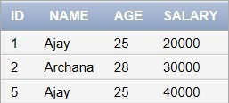

BETWEEN

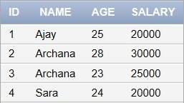
select * from salary where salary between 20000 and 30000;
IS NOT NULL

select * from salary where age is not null;
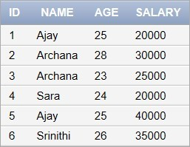
IS NULL

select * from salary where age is null;
no data found

(4,'Kumaran',25,'CBE',24000);
Sub queries with the INSERT Statement
INSERT INTO customers_backup SELECT * FROM CUSTOMERS WHERE ID IN
(SELECT ID
FROM CUSTOMERS) ;
4 rows inserted
select * from customers_backup;
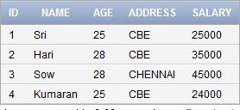

Sub queries with the UPDATE Statement

UPDATE CUSTOMERS
SET SALARY = SALARY * 0.25 WHERE AGE IN
(SELECT AGE FROM customers_backup WHERE AGE >= 27 );
Select * from customers;
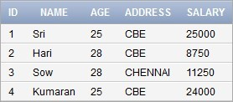

Subqueries with the DELETE Statement

DELETE FROM CUSTOMERS WHERE AGE IN
(SELECT AGE FROM CUSTOMERS_backup WHERE AGE >= 27 );
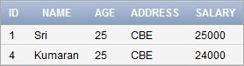
select * from customers;
select age from customers where exists (select age from salary where salary > 25000);
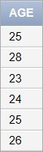
JOINS

CREATE and INSERT values in TABLE(cust)

create table cust(id int primary key,name varchar(20),age int); insert into cust values(1,'aaa',32);
insert into cust values(2,'aba',32); insert into cust values(3,'abc',32); insert into cust values(4,'ccc',25); select * from cust;
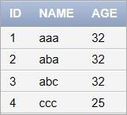

CREATE and INSERT values in TABLE(order1)

create table order1(oid int primary key,custid int,amount int); insert into order1 values(101,1,1000);
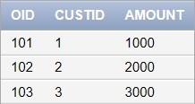
insert into order1 values(102,2,2000); insert into order1 values(103,3,3000);

INNER JOIN Syntax:
SELECT table1.column1, table2.column2... FROM table1
INNER JOIN table2
ON table1.common_filed = table2.common_field;

Example:

select id,name,oid,amount
from cust
inner join order1
on cust.id=order1.custid;
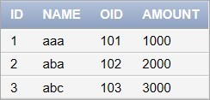

LEFT JOIN: Syntax:

select table1.column1, table2.column2... from table1
left join table2
on table1.common_filed = table2.common_field;

Example:
select id,name,oid,amount from cust
left join order1
on cust.id=order1.custid;
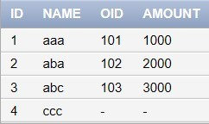

RIGHT JOIN:
Syntax:
select table1.column1, table2.column2... from table1
right join table2
on table1.common_filed = table2.common_field;

Example:
select id,name,oid,amount from cust
right join order1
on cust.id=order1.custid;
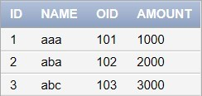

FULL JOIN: Syntax:

select table1.column1, table2.column2... from table1
full join table2
on table1.common_filed = table2.common_field;

Example:
select id,name,oid,amount from cust
full join order1
on cust.id=order1.custid;
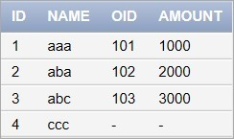

EX.NO:5 NATURAL, EQUI AND OUTER JOIN DATE:

Aim
To write DQL Commands to join, Restrict and Retrieve information from one or more
tables execute it and verify the same.

Algorithm
Selecting Rows with Equijoin using table Aliases

Write a query to display empid,name,deptid,deptname and location for allemployees and verify it.

SQL> select employee.empid,employee.name,employee.depid,department.deptname,depa rtment.location from employee,department where employee.depid=department.depid;

EMPID NAME DEPID DEPTNAME LOCATION

a123 | ragu | CS000 | COMPUTER_SCIENCE | CHENNAI
a124 | rama | CS000 | COMPUTER_SCIENCE | CHENNAI
a125 | ram | EE000 | ELECT_ELECTRO | MUMBAI
a128 | sag | EE000 | ELECT_ELECTRO | MUMBAI
c128 | dinesh | EC000 | ELECT_COMM | DELHI
d124 | abc | EC000 | ELECT_COMM | DELHI

- rows selected.

- Write a query to display the “dinesh” depid and deptname and verify it.

SQL> select e.empid, e.name,e.depid,d.deptname from employee e,department d wheree.depid=d.depid and e.name='dinesh';

EMPID | NAME | DEPID |  | DEPTNAME
c128 | dinesh | EC000 |  | ELECT_COMM

Selecting Rows with Non-Equijoin using table Aliases: [Other Conditions such as >=, <= and BETWEEN, AND ]

1.Write a query to display the name,salary and deptname of all employees whose salary is greater than 10000 and verify it.

SQL> select e.name,e.salary,d.deptname from employee e,department d where e.salary>10000and e.depid=d.depid;

NAME | SALARY | DEPTNAME
ragu | 200000 | COMPUTER_SCIENCE
rama | 200000 | COMPUTER_SCIENCE
ram | 30000 | ELECT_ELECTRO

Selecting Rows using Outer Joins:[ Left Outerjoin,Right Outerjoin using ”+” symbol ]

Write a query to display the name, depid and deptname of all employees.Make surethat employees without department are included as well and verify it.

SQL> select e.name,e.depid,d.deptname from employee e,department d where e.depid
=d.depid(+);

NAME DEPID DEPTNAME

rama | CS000 | COMPUTER_SCIENCE
ragu | CS000 | COMPUTER_SCIENCE
sag | EE000 | ELECT_ELECTRO
ram | EE000 | ELECT_ELECTRO
abc | EC000 | ELECT_COMM
dinesh www | EC000 | ELECT_COMM

- rows selected.

Write a query to display the name, salary,depid and deptname of all employees. Makesure that departments without employees are included as well and verify.

SQL> select e.name,e.salary,e.depid,d.deptname from employee e,department d where e.depid(+)=d.depid;

NAME SALARY DEPID DEPTNAME

ragu | 200000 |  | CS000 |  | COMPUTER_SCIENCE
rama | 200000 |  | CS000 |  | COMPUTER_SCIENCE
ram | 30000 |  | EE000 |  | ELECT_ELECTRO
sag | 10000 |  | EE000 |  | ELECT_ELECTRO
dinesh | 10000 |  | EC000 |  | ELECT_COMM
abc | 5000 |  | EC000 |  | ELECT_COMM
 |  |  |  |  | MECHANICAL CHEMICAL
8 rows selected

RESULT:
Thus the SQL commands to execute natural, equi and outer joins are executed successfully.

EX.NO:6 PROCEDURES AND FUNCTIONS

DATE:

AIM:
To implement and execute Procedures in Oracle Database using Procedural Language concepts.

PROCEDURES:
- Procedure is a sub program used to perform an action.
- Replace-recreates the procedure if it already exists.

3 MODES:
- IN – Means you must specify a value for the argument at the time execution of the procedure.

- OUT-passes back a value to its calling program.

- INOUT – When calling the procedure, yu must specify the value and that procedures passes value back to the calling procedure

CREATING A PROCEDURE SYNTAX:
CREATE [OR REPLACE] PROCEDURE procedure_name [(column_name [IN | OUT | IN OUT] type [, ...])]
{IS | AS} BEGIN
< procedure_body > END procedure_name;

EXAMPLE:

CREATE OR REPLACE PROCEDURE greetings AS
BEGIN
dbms_output.put_line('Hello World!'); END;

To run this procedure

BEGIN
greetings; END;

DELETING A PROCEDURE SYNTAX:
DROP PROCEDURE procedure-name;

EXAMPLE:

DROP PROCEDURE greetings;

Procedure dropped

EXAMPLE 2

Create a table user1

create table user1(id number(10) primary key,name varchar2(100));

Create the procedure

create or replace procedure
INSERTUSER(id IN NUMBER, name IN VARCHAR2)
is begin
insert into user1 values(id,name); end;

To execute the procedure

BEGIN INSERTUSER(101,'Rahul');
dbms_output.put_line('record inserted successfully'); END;

PL/SQL FUNCTIONS

SYNTAX:

CREATE [OR REPLACE] FUNCTION function_name [parameters] [(parameter_name [IN | OUT | IN OUT] type [, ...])]
RETURN return_datatype

{IS | AS} BEGIN
< function_body > END [function_name];

create or replace function adder(n1 in number, n2 in number) return number
is
n3 number(8); begin
n3 :=n1+n2; return n3; end;

EXECUTE THE FUNCTION

DECLARE
n3 number(2); BEGIN
n3 := adder(11,22); dbms_output.put_line('Addition is: ' || n3);
END;

Output:

Addition is: 33 Statement processed.

RESULT:
Thus the PL/SQL procedures and functions are executed successfully

